**Big O**

* **Section Overview:**

**Big O – Asymptotic Analysis**

* **What is good code?**



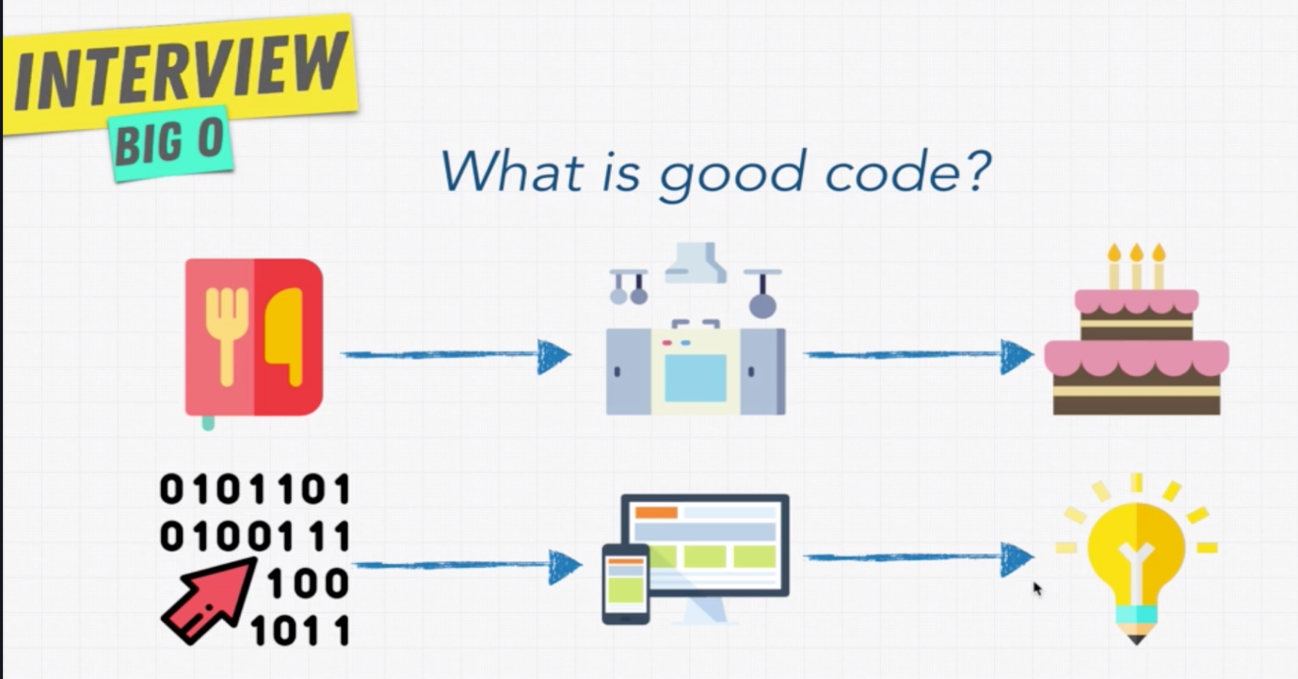

Note: As like there are multiple ways to cook a cake in kitchen, there are multiple ways to achieve the output for given problem with programming.

<https://repl.it>

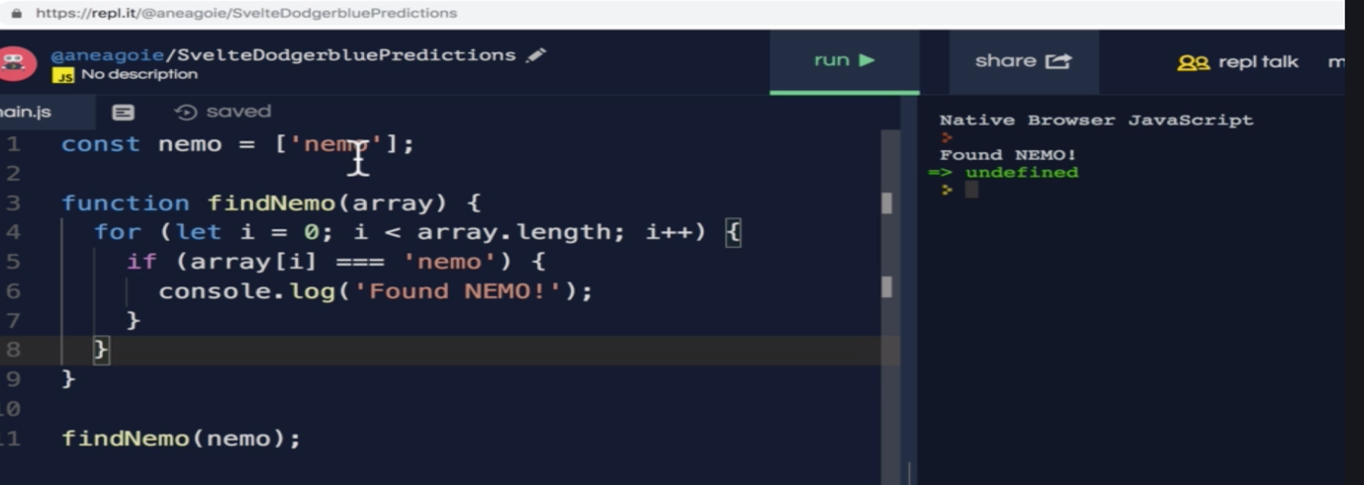

Above code is simple js code, which searches and prints the given array contains “nemo”, how do we measure the performance of this code?

* **Big O and Scalability:**

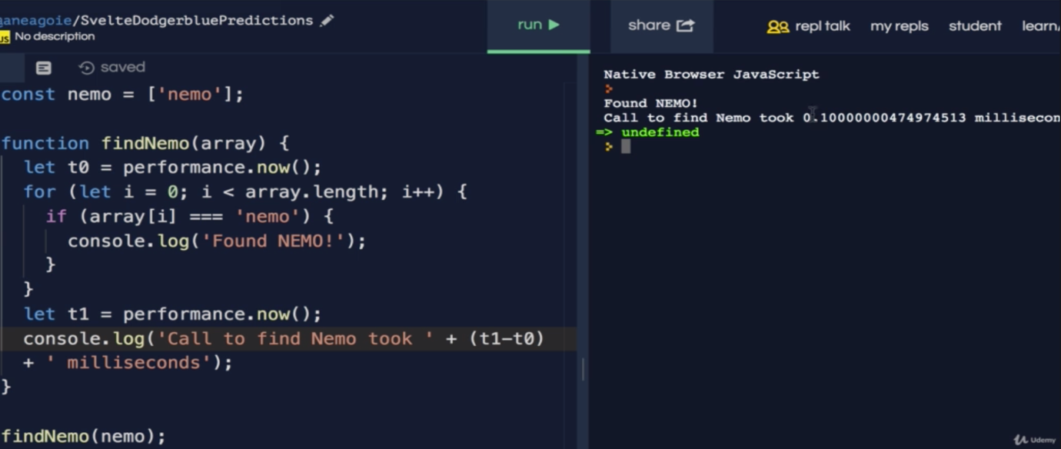

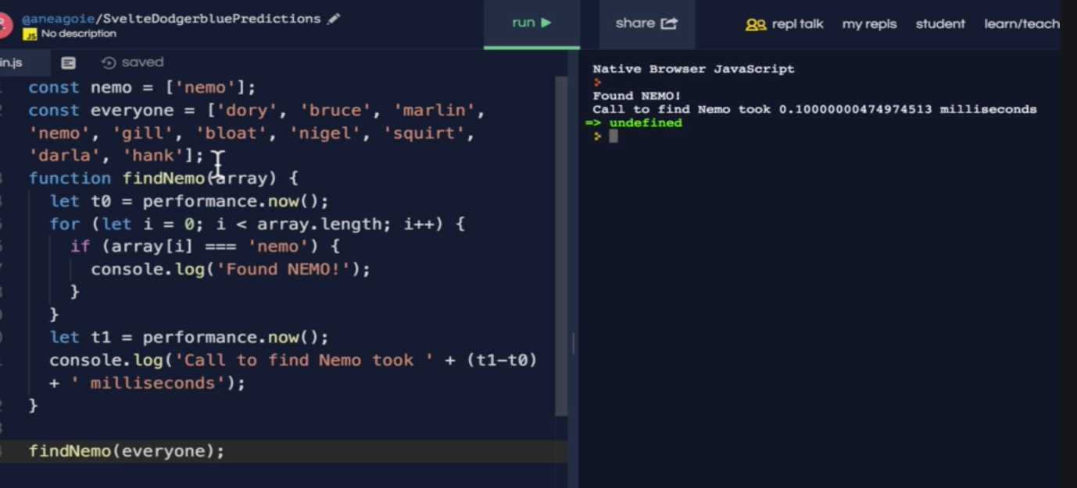

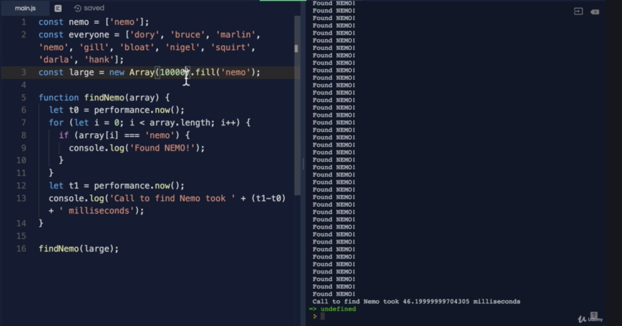

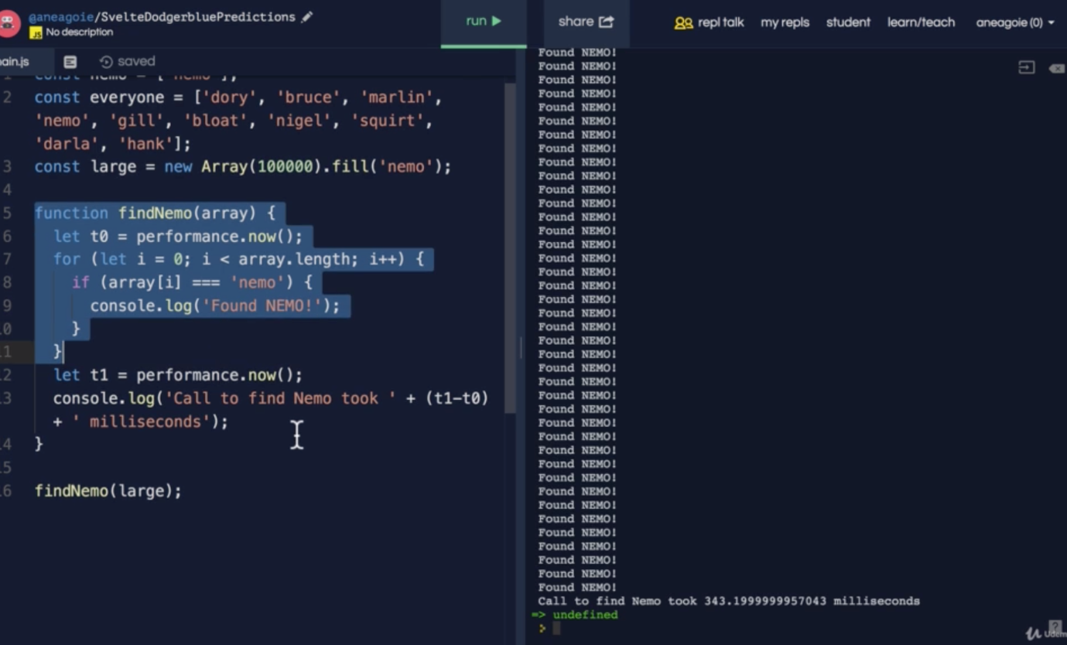

We measured the performance of the code, but this may vary whenever we run the same code on different machines. So how do we measure the performance of a code?

Big O notation is used to measure the performance of the code. Regardless of the computer differences.

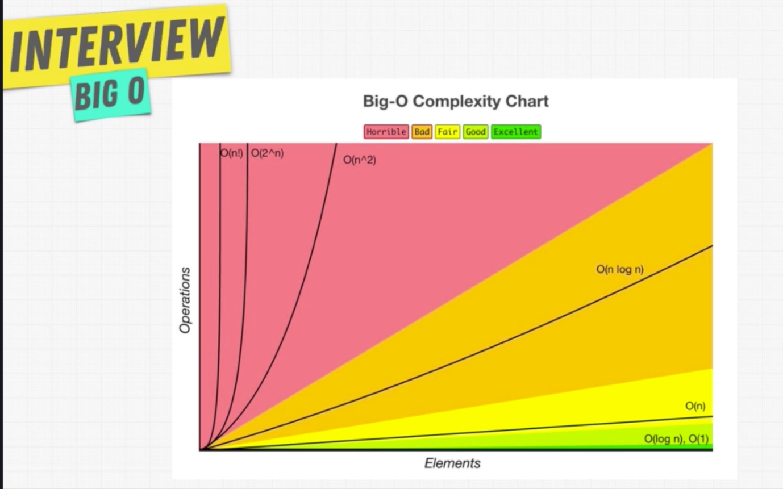

Algorithmic efficiency.

Note: In our example, we measured the performance based on the time it took, whereas Big O measures the performance based on the number of operations an algorithm do.

* **O(n)**

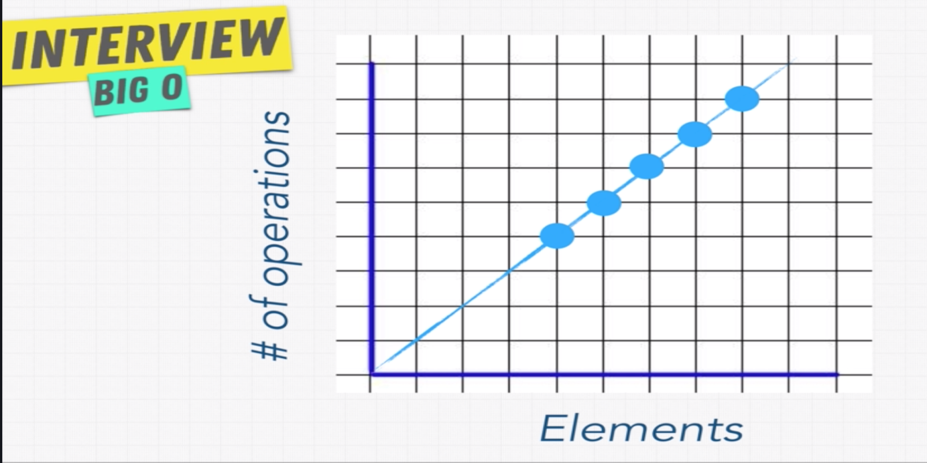

Note: In above figure, we can draw a straight line on the dots, which is linear.

O(n) 🡪 Linear Time

In Big O ‘n’ stands for Number of.

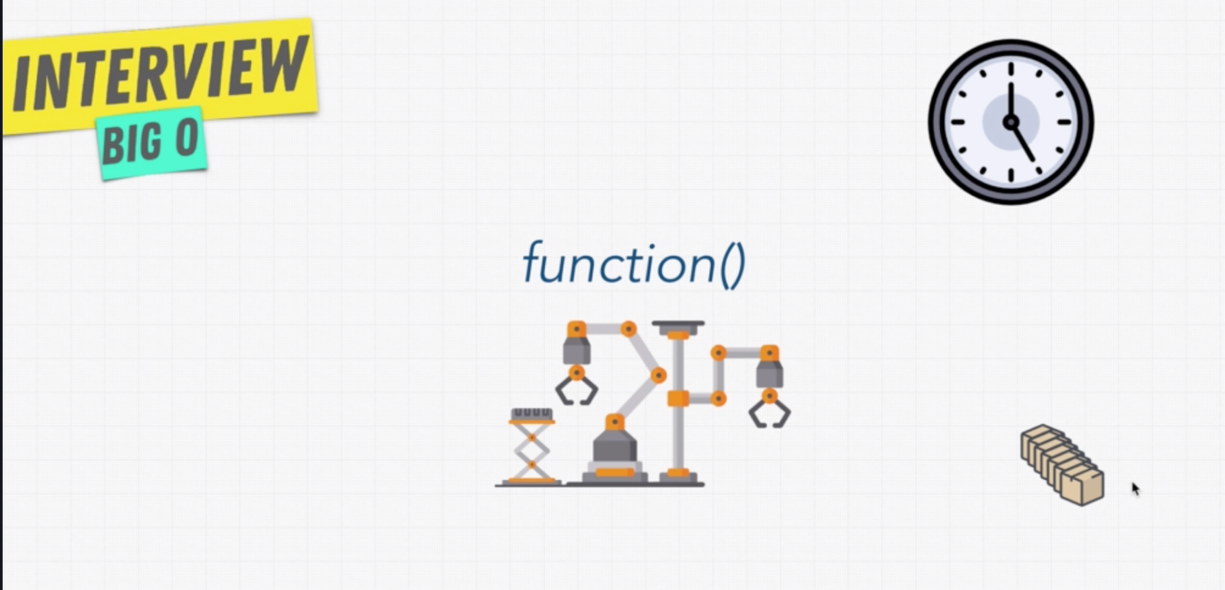

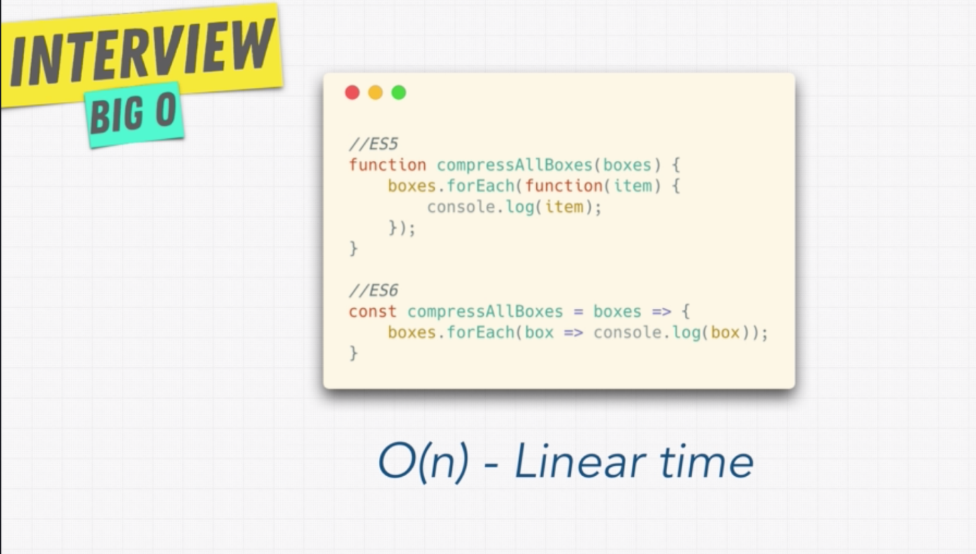

* **O(1)**

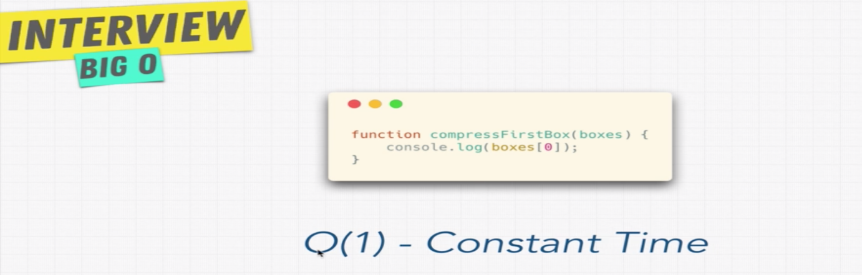

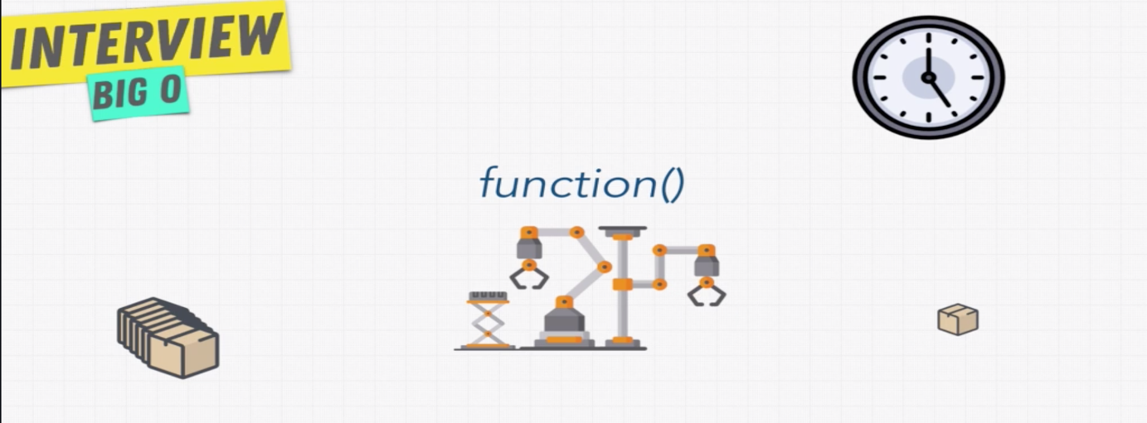

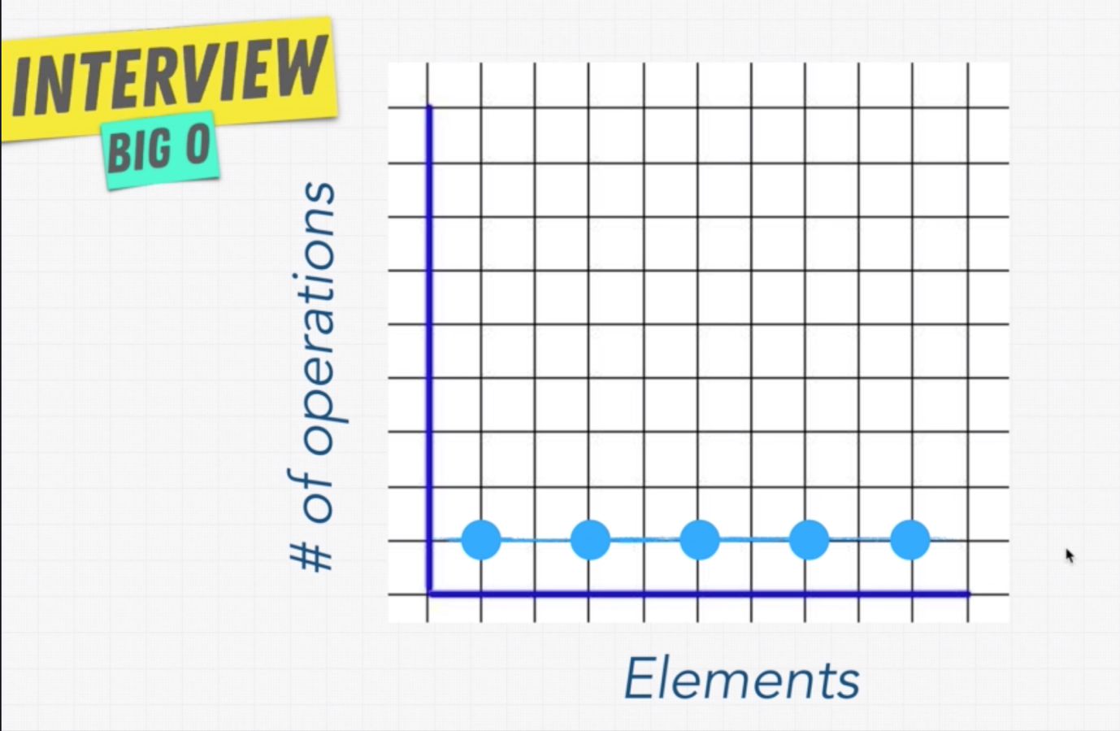

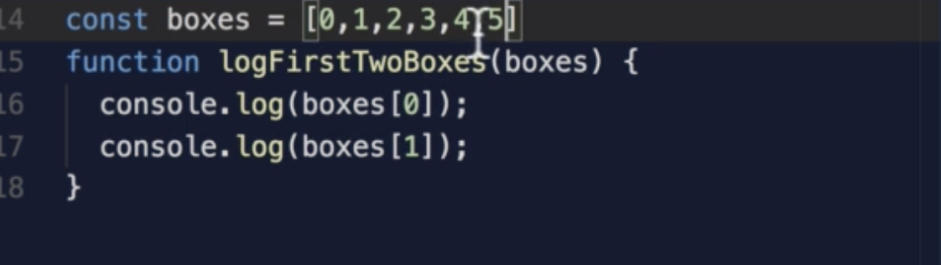

How do we measure Big O for above function?

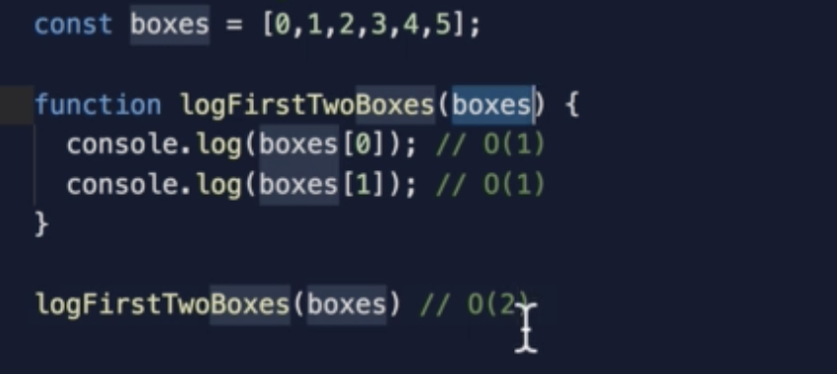

The number of operations in above function is always 2 independent of the input, so still it is O(1)

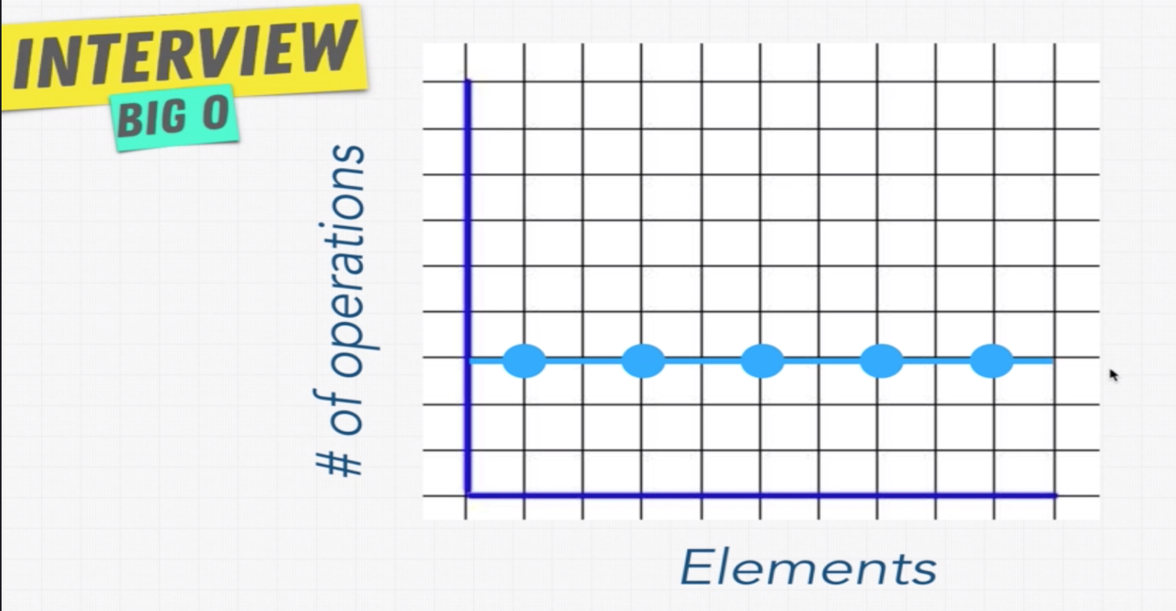

* **Exercise Big O Calculation – 1:**

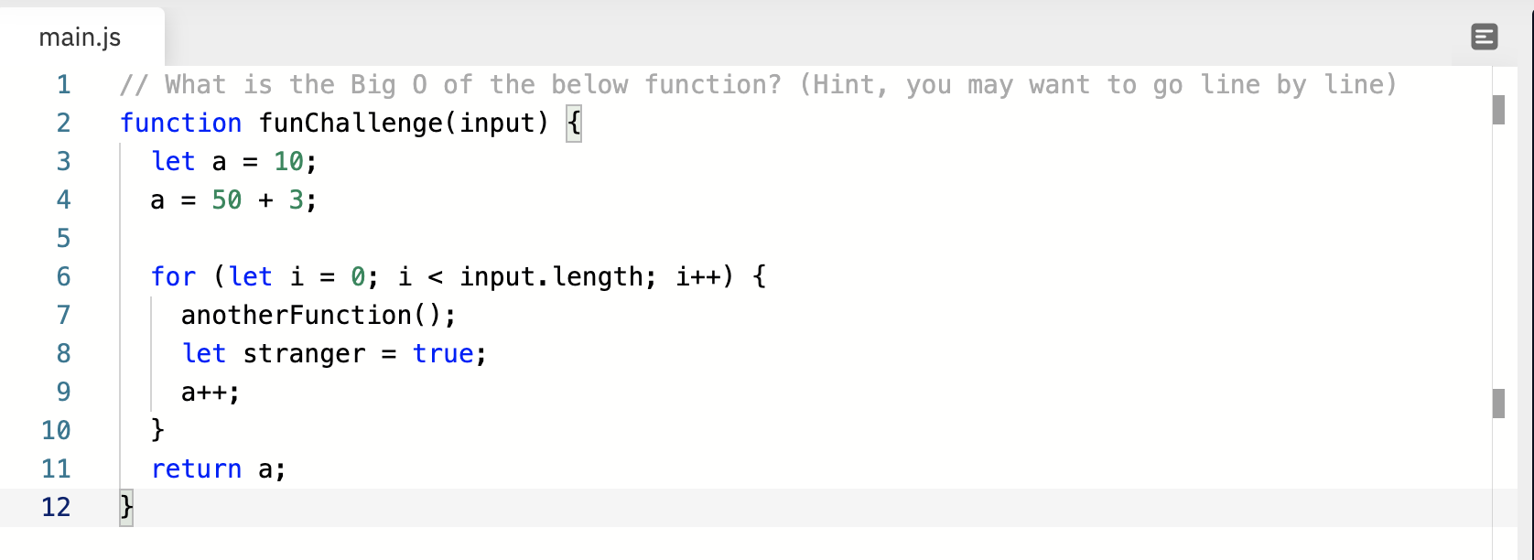

* **Solution – Big O**

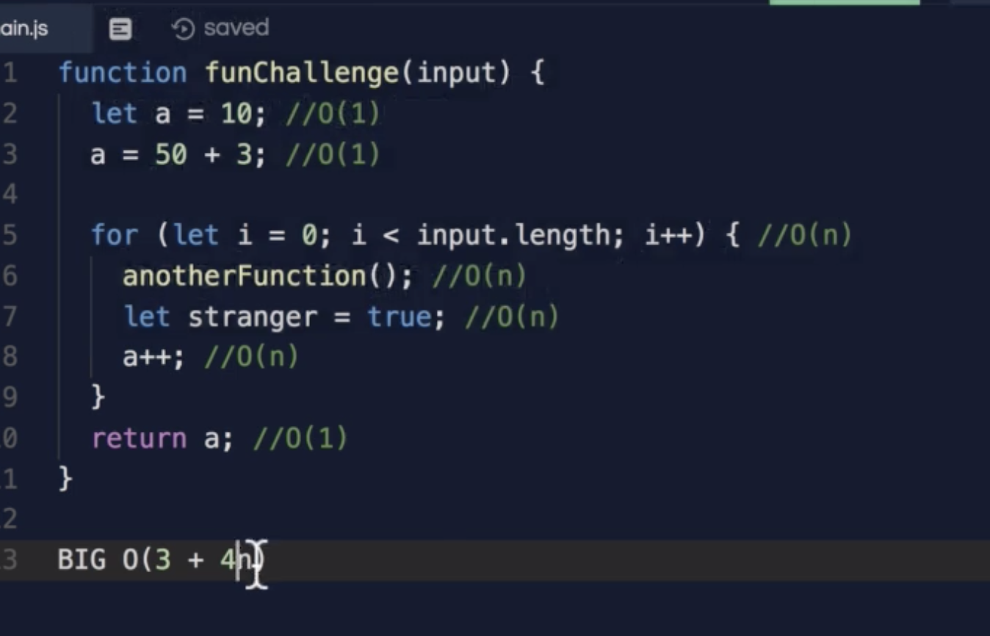

**Is simplified to O(n)**

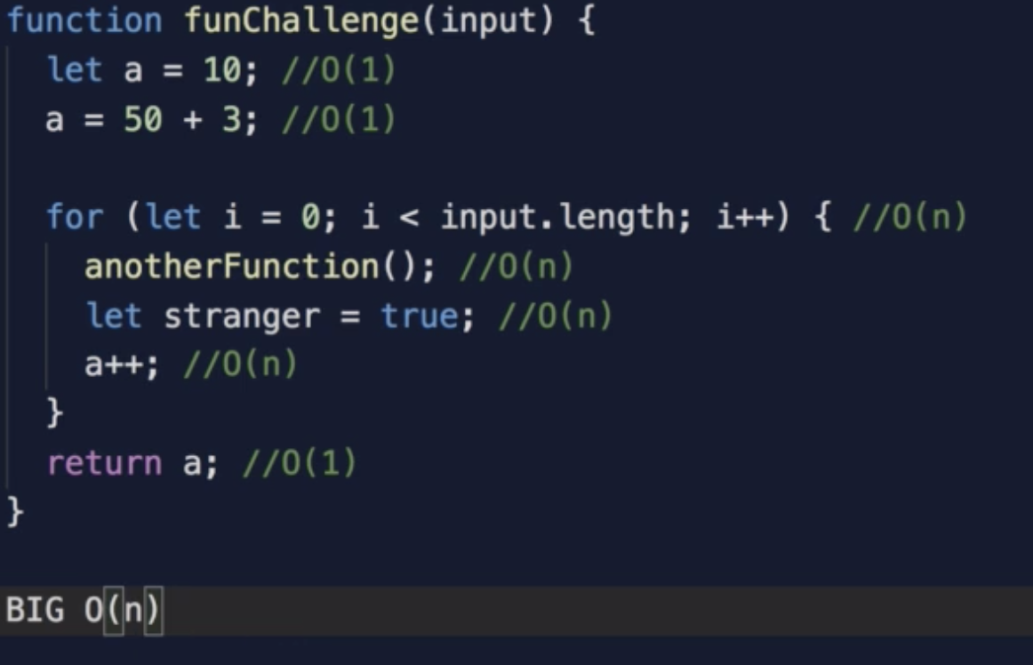

* **Exercise Big O Calculation – 2:**

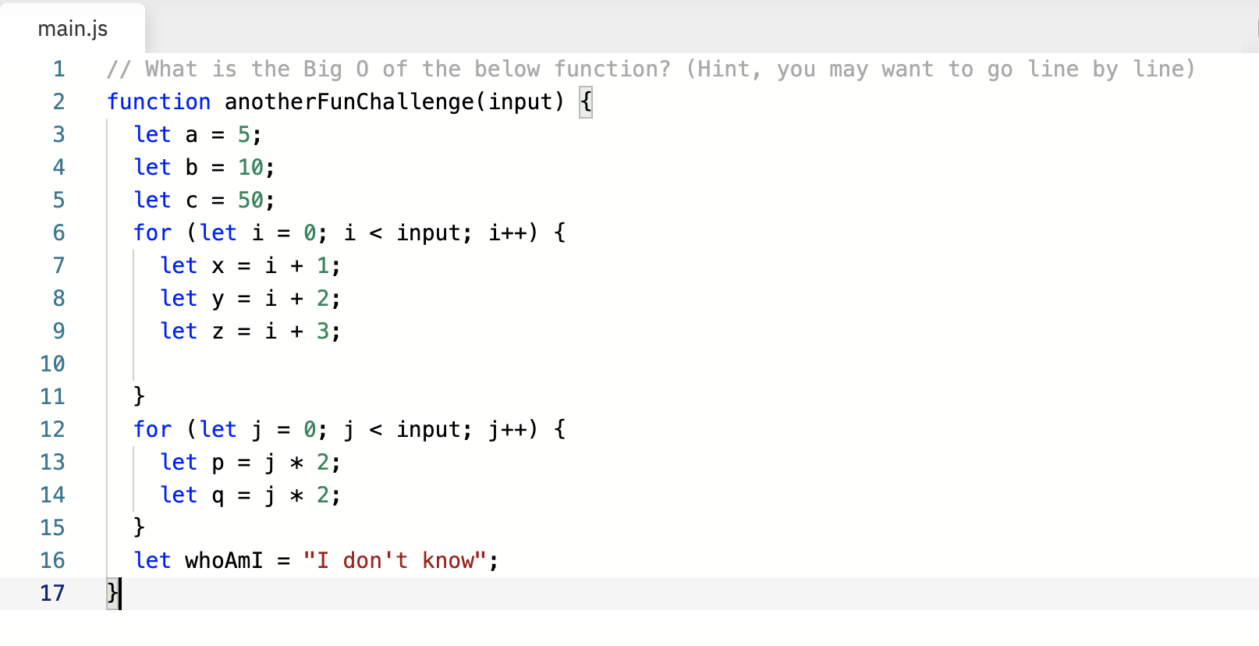

* **Solution: Big O Calculation 2:**

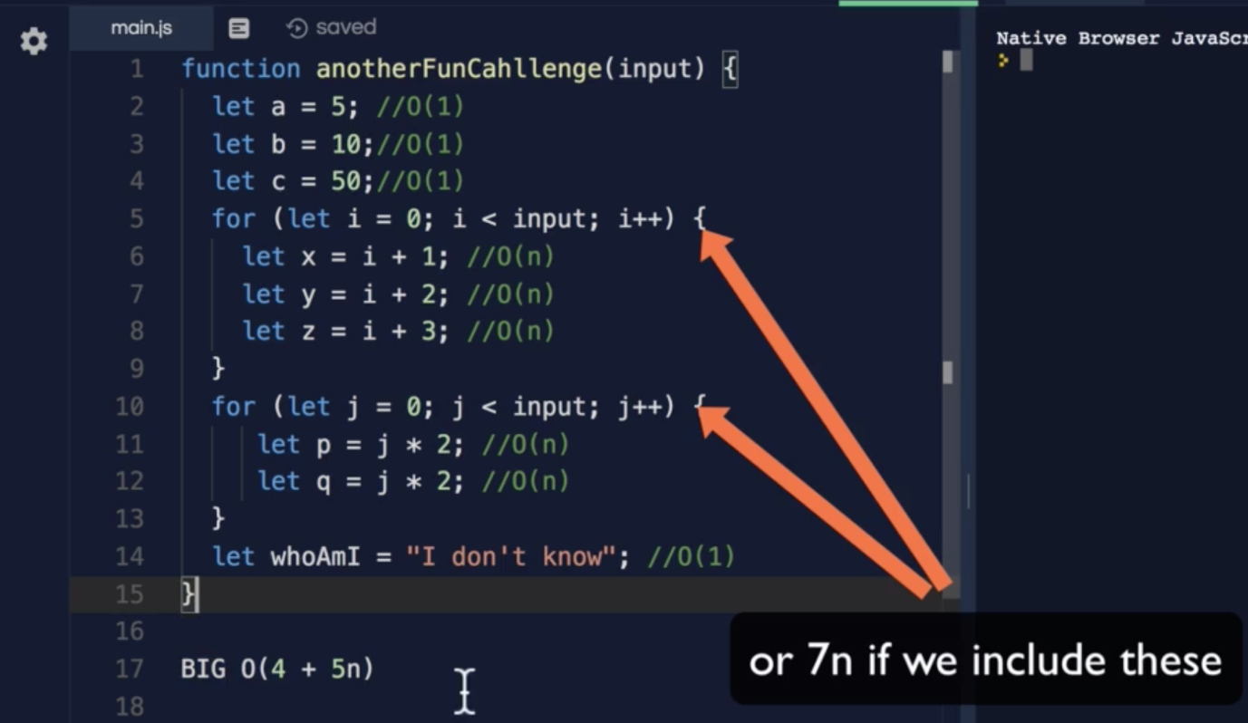

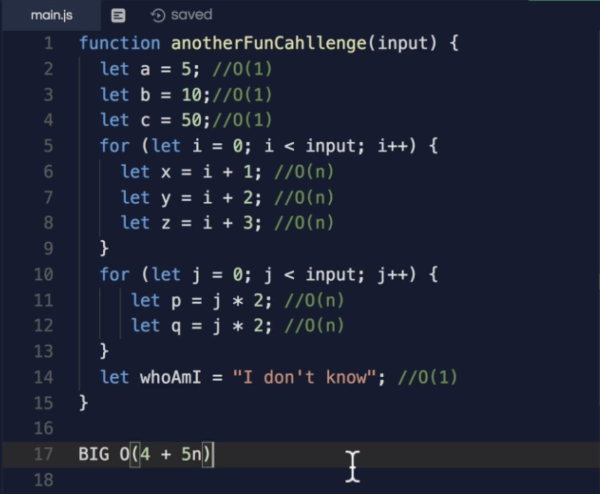

* **Simplifying Big O:**

The method we followed above is just for understanding purpose, we can’t use this in the interview, there are few rules to calculate Big O, rather that calculating each operation.

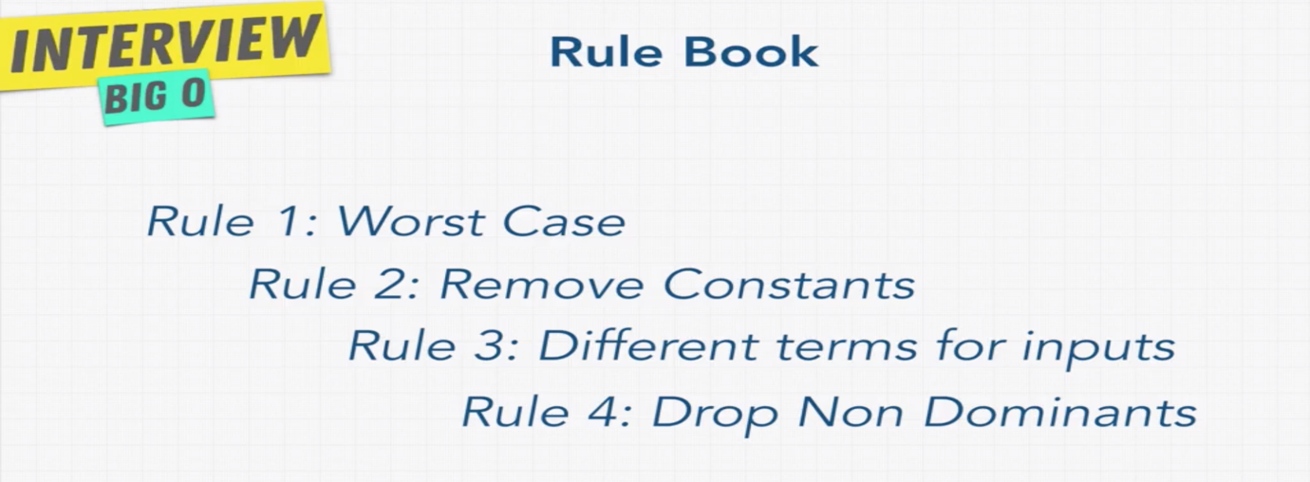

* **Big O Rule 1:**

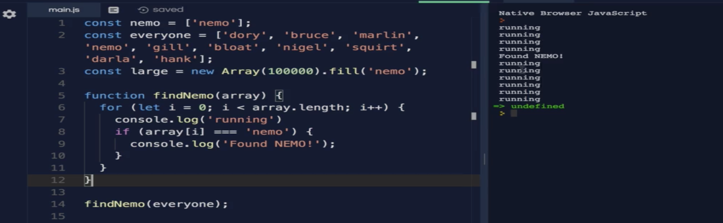

Rule -1 talks about the worst case:

Which means, what is the worst case of the given algorithm. In our first example, we are trying to find “nemo” from the input. As per the initial code, even after finding the word from input, we are still looping. It executes 10 times if the size of the input is 10.

We can do a simple change, once you found the word, exit from the loop as below.

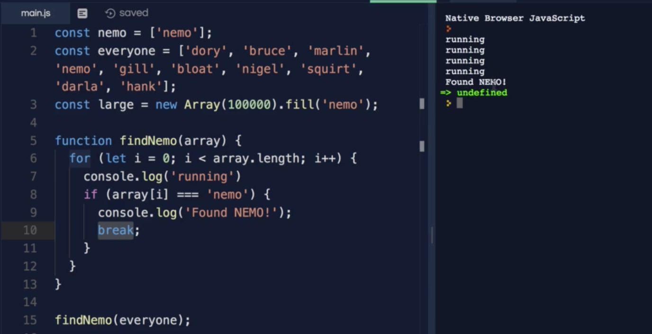

But still this will not guarantee always it executes 4 times, its all depend on the input, if the “nemo” is last item of the array, still it goes for n number of iterations, so the Big O is O(n).

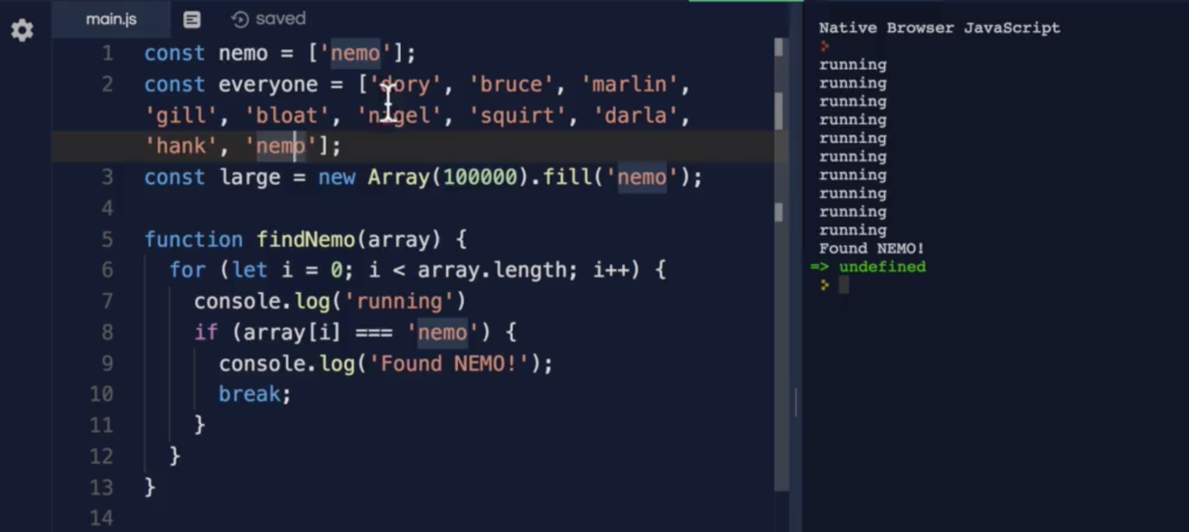

Let’s apply same analogy here, if I’m trying to find the yellow box from the array of boxes, the Big O depends on where the yellow box at the array, if it is at first location, the iterations will be less, if it is at last item, the iterations will be equal to n.

So if we calculate the worst case, it will be always O(n).

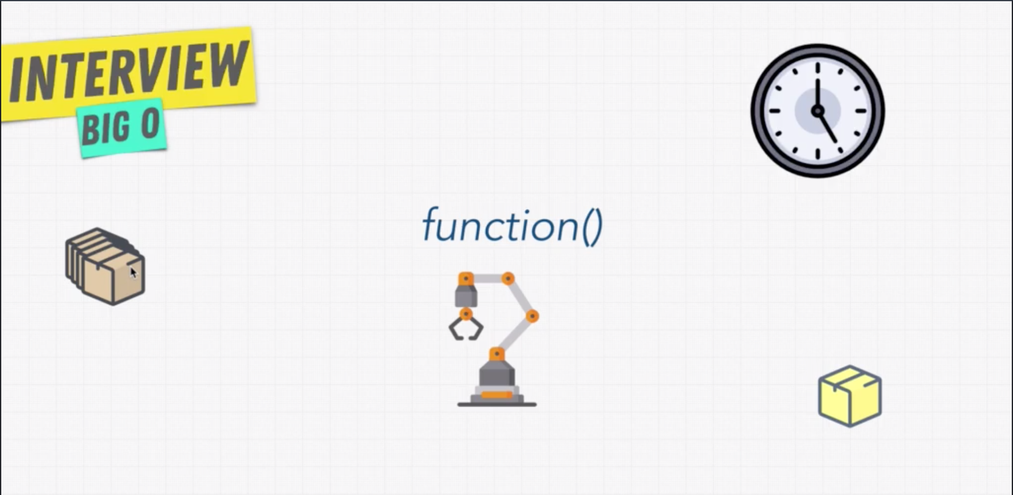

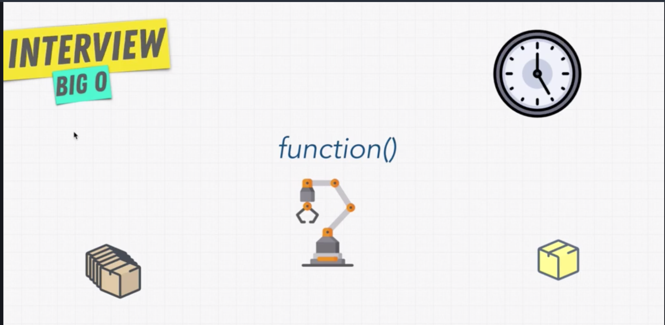

* **Big O Rule 2:**

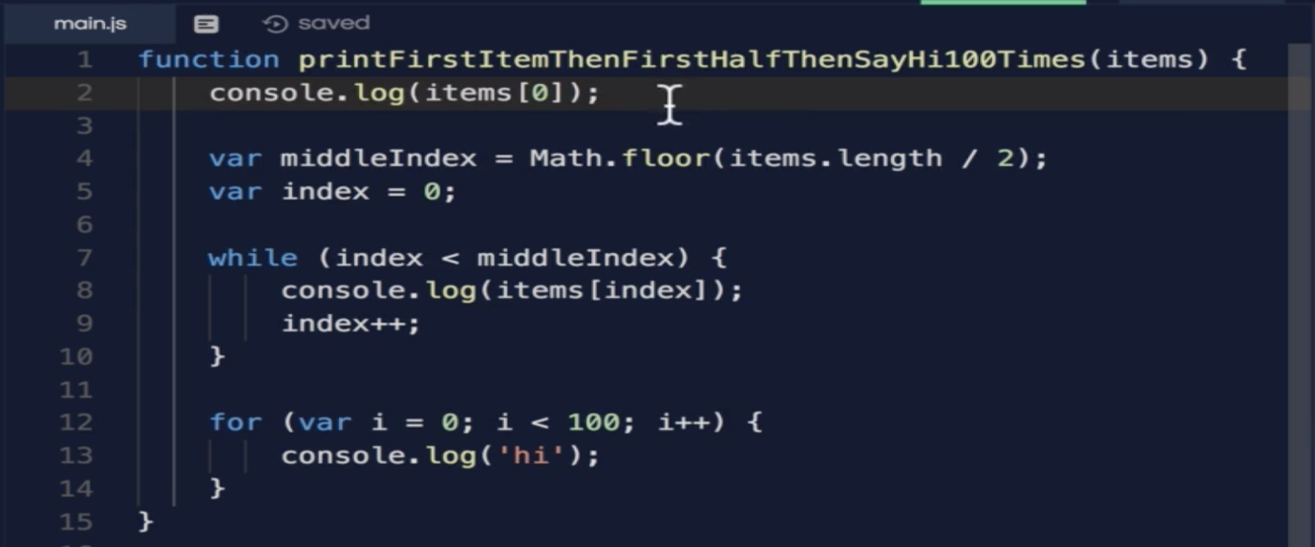

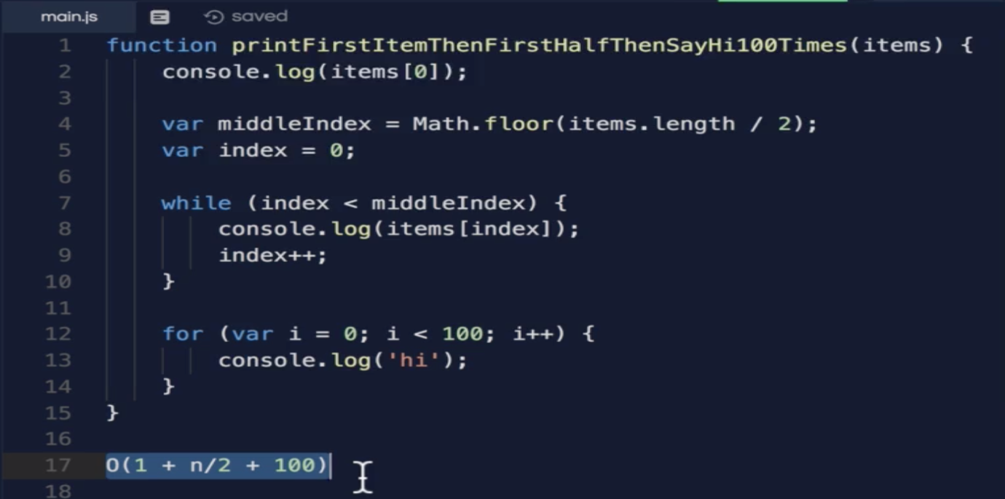

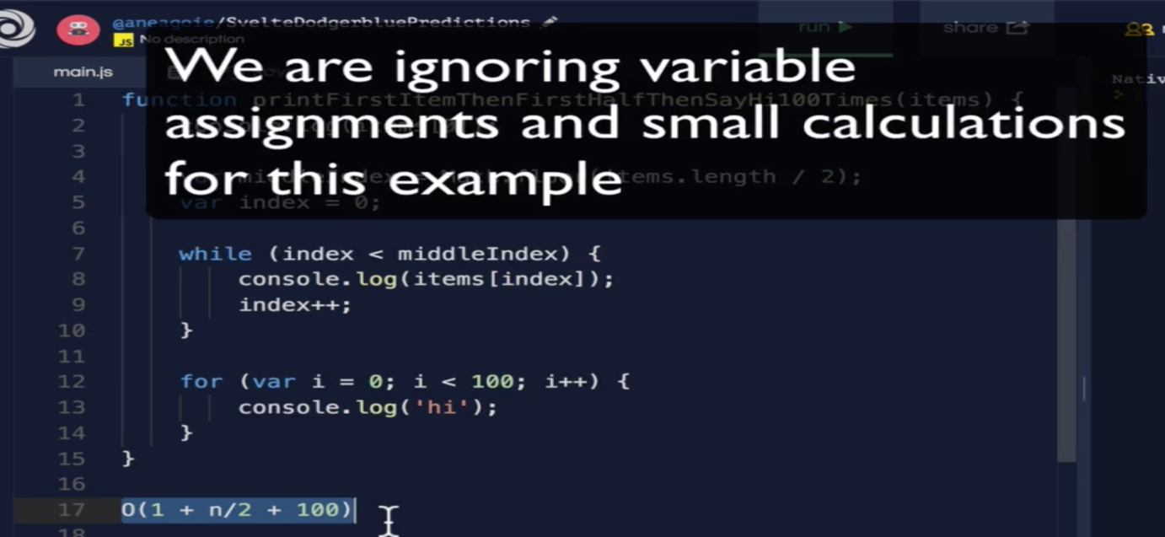

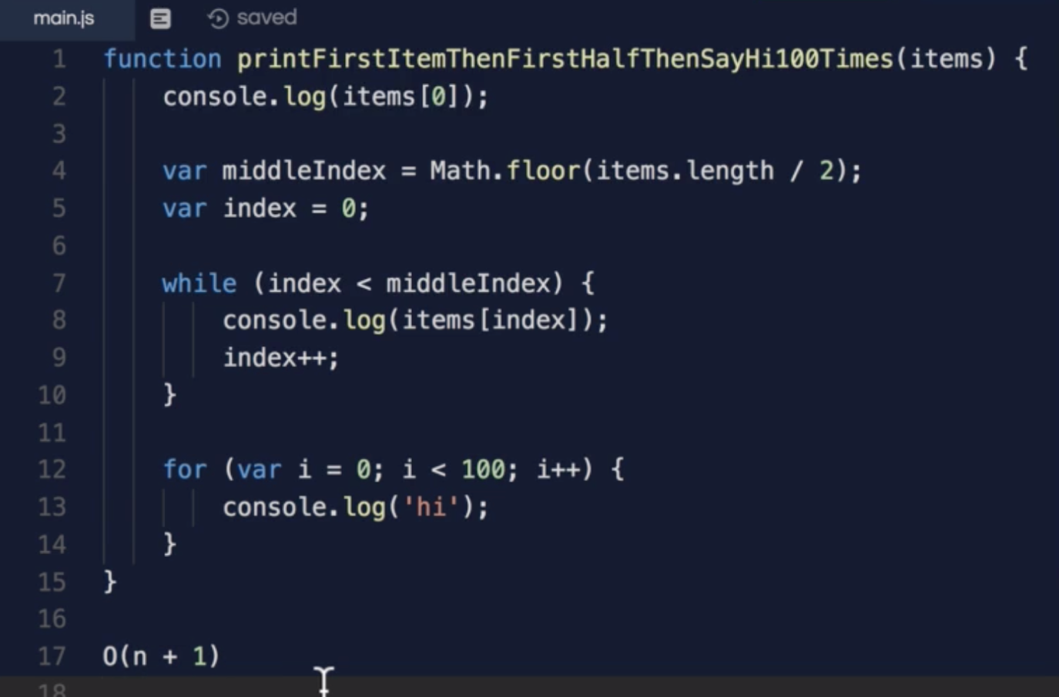

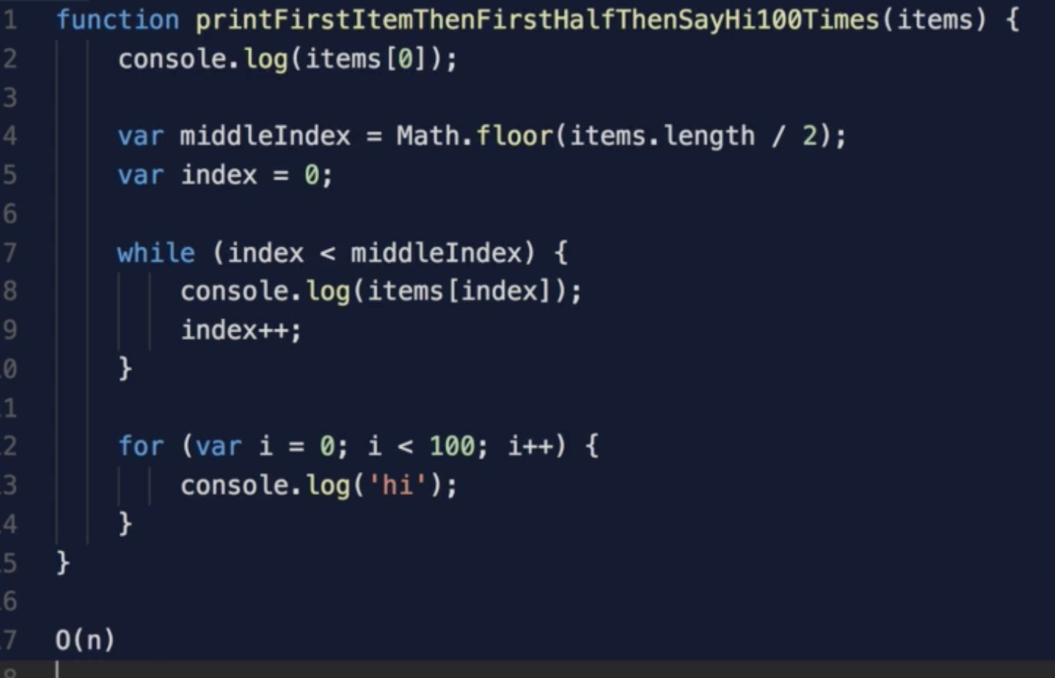

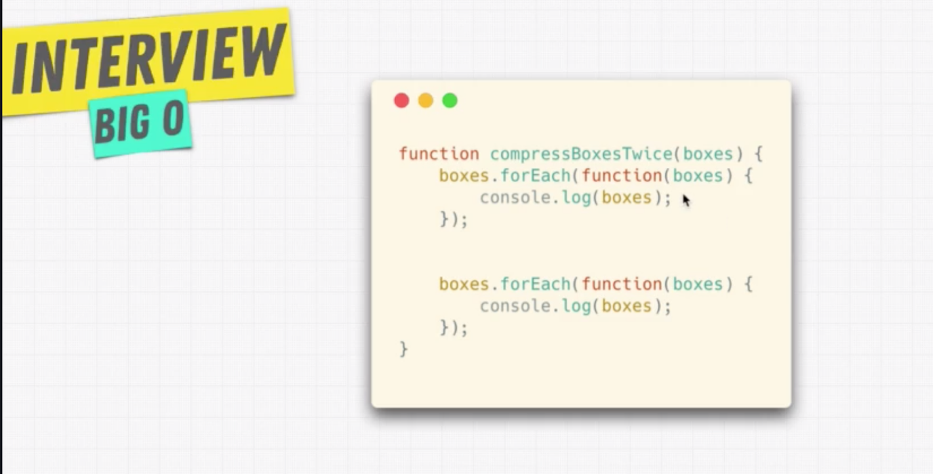

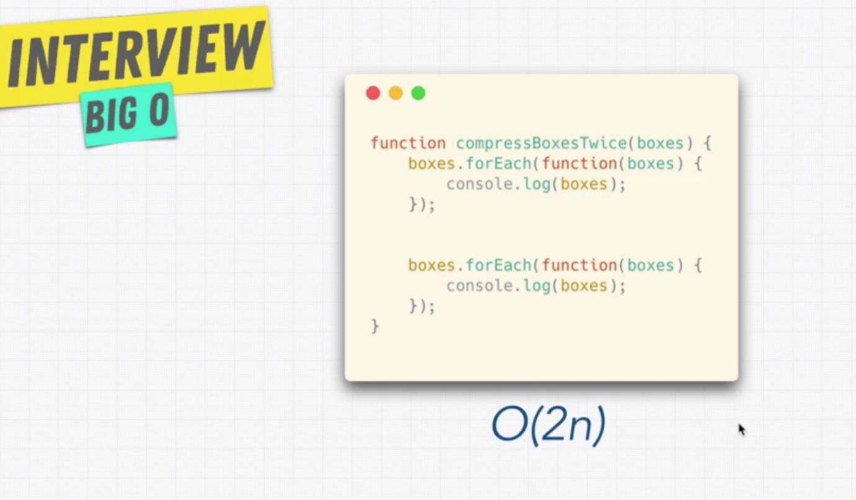

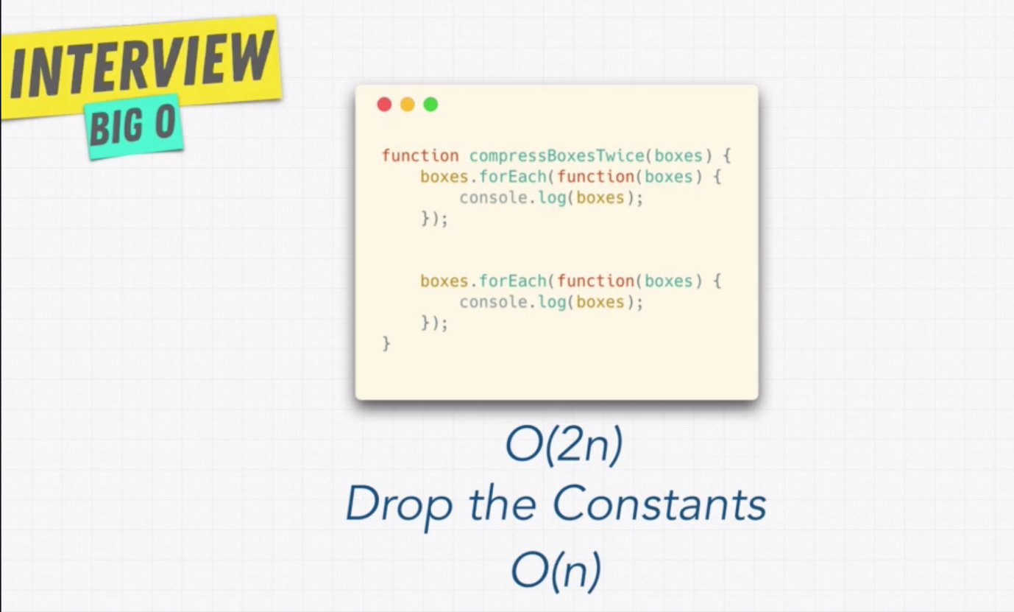

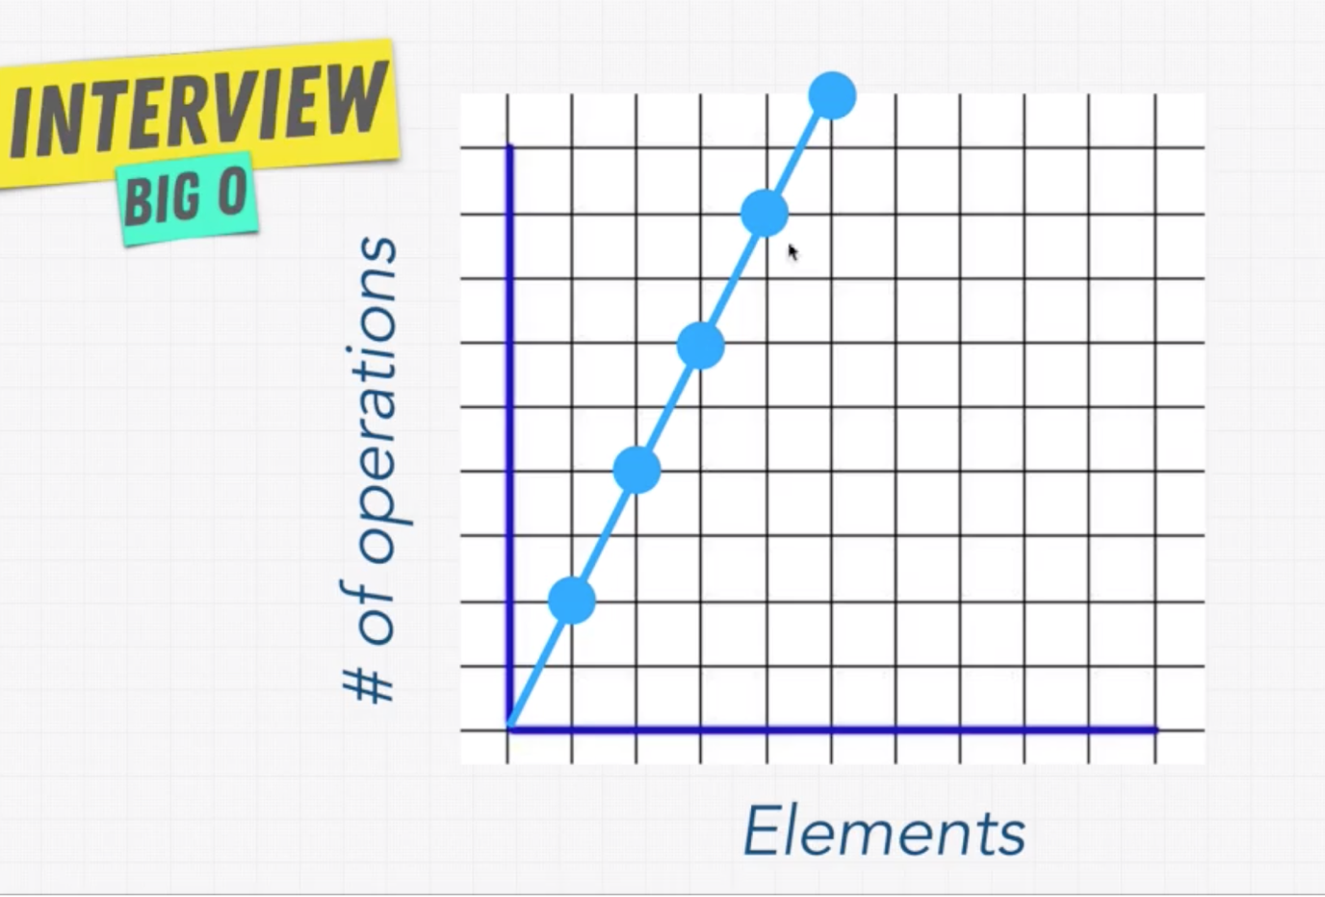

* **Big O Rule 3:**

**Rule: Different terms for input.**

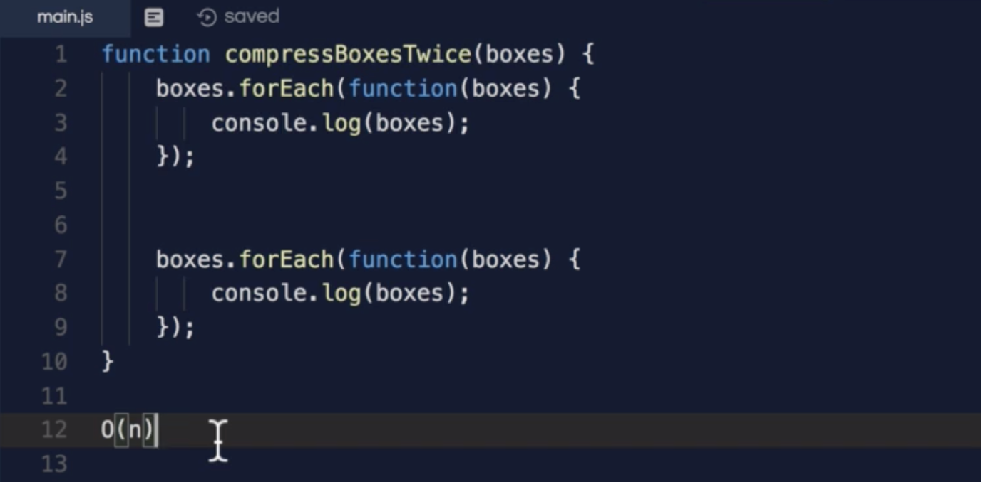

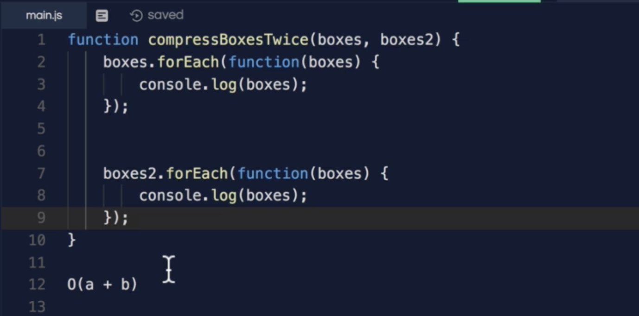

**Note: If a function has two loops it doesn’t mean that it always loops the same input, it depends on the number of inputs, in above example, first loop uses the first input, and the second uses the second input. So we have to consider different input.**

* **O(n^2):**

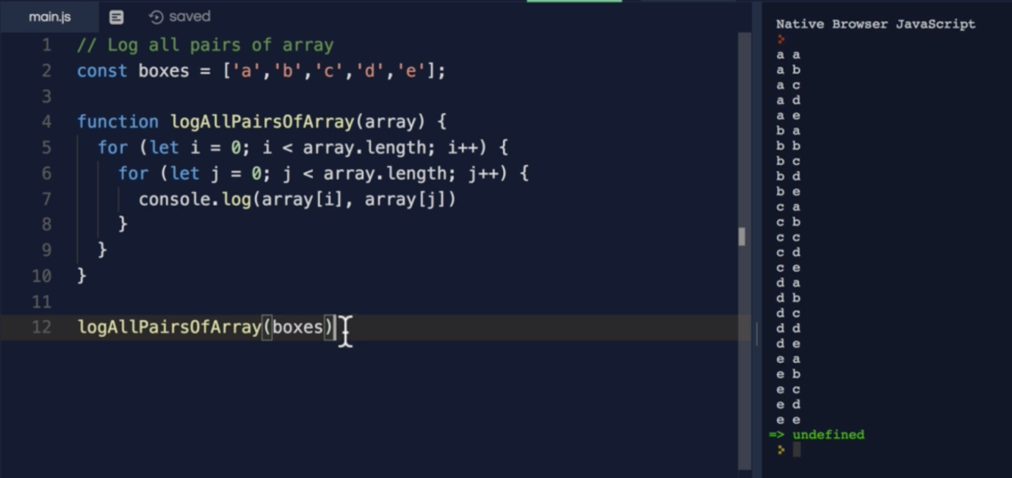

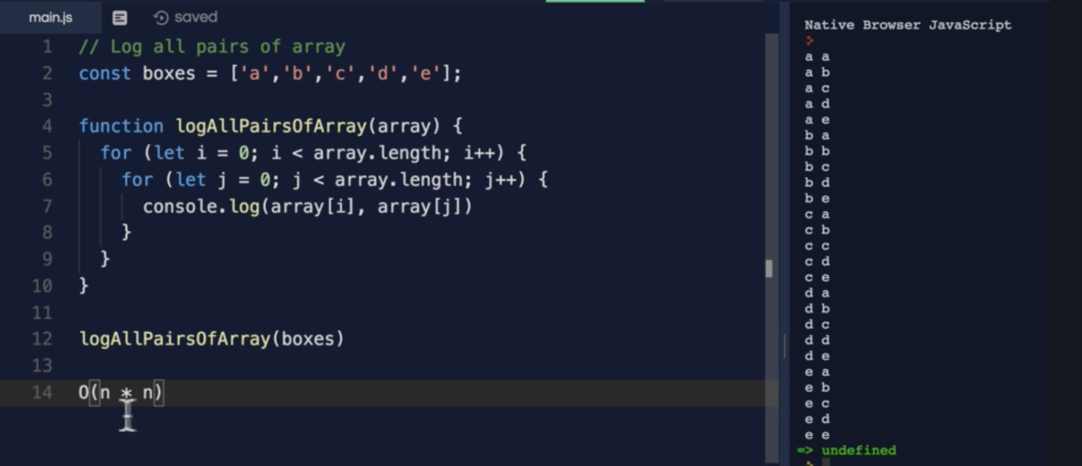

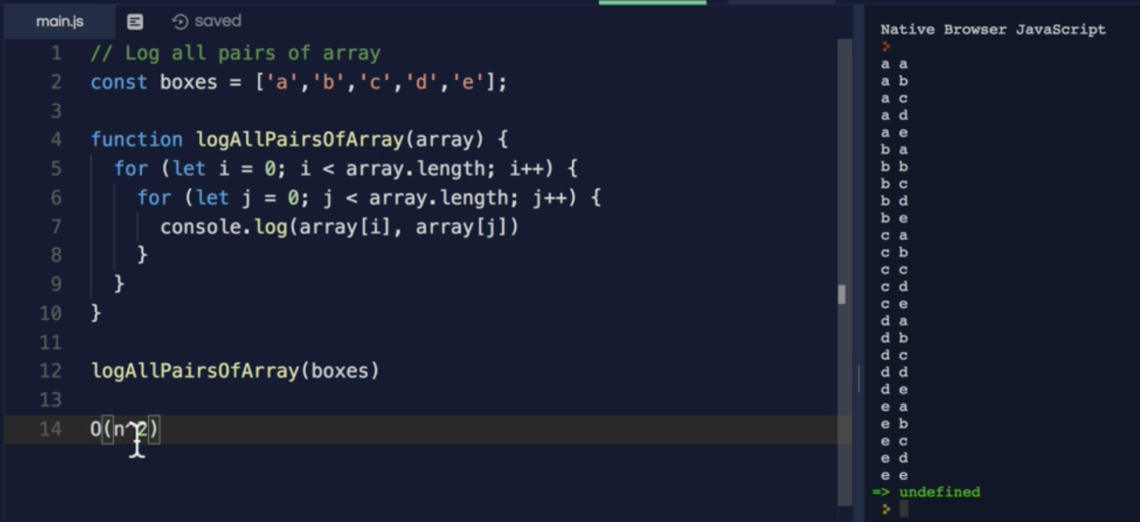

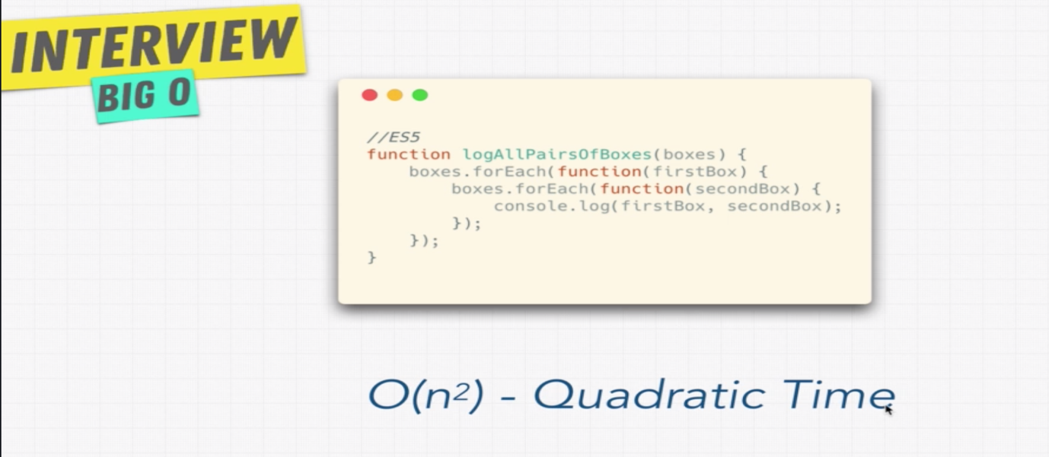

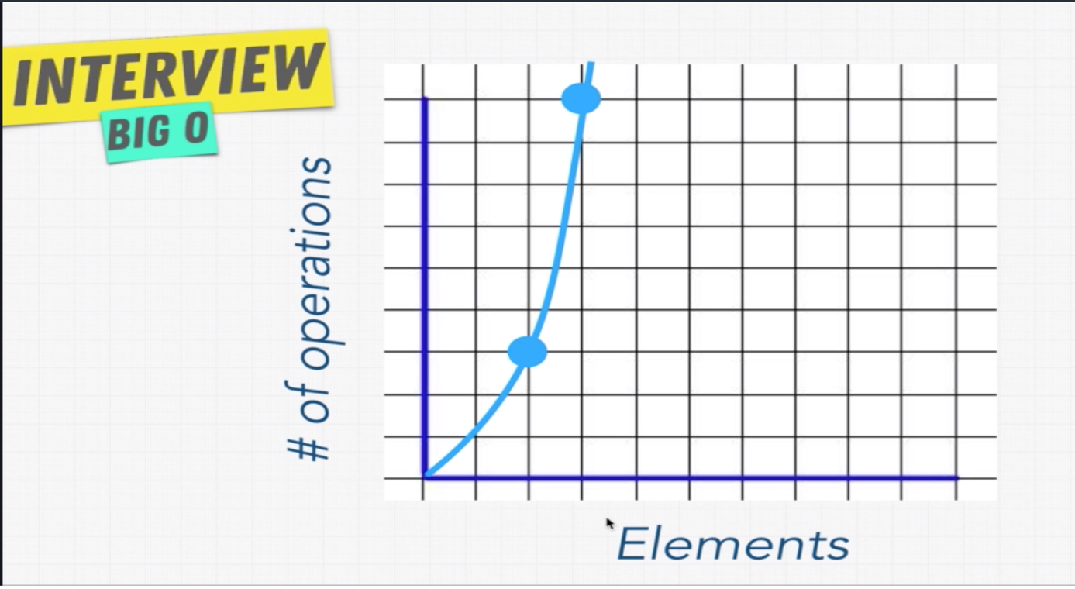

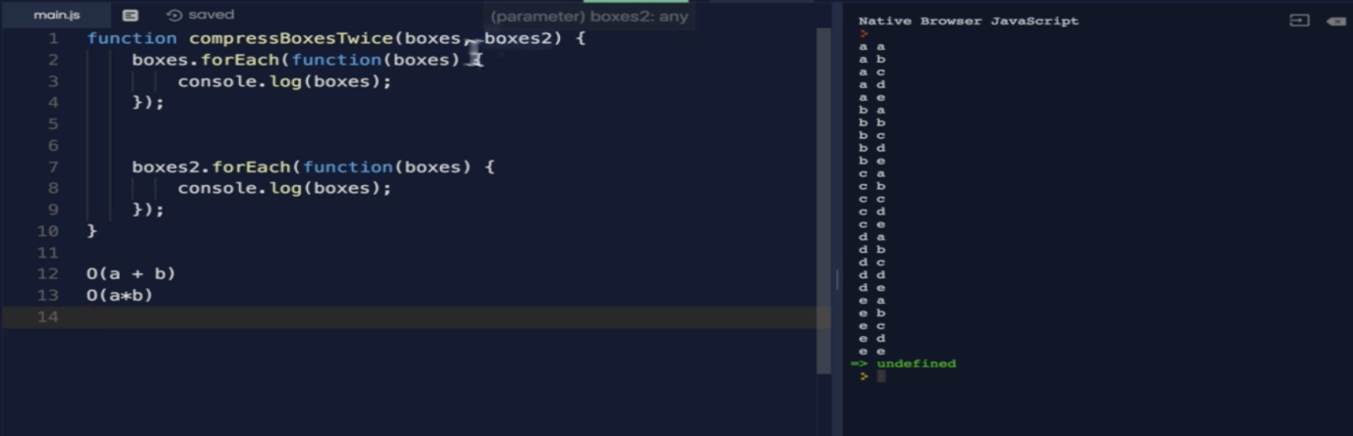

**Note: If an array iteration is at same indentation, then use (a+b), if they are at different indentation, nested loop, then (n^2).**

* **Big O Rule 4:**

**Rule: Drop Non Dominants**

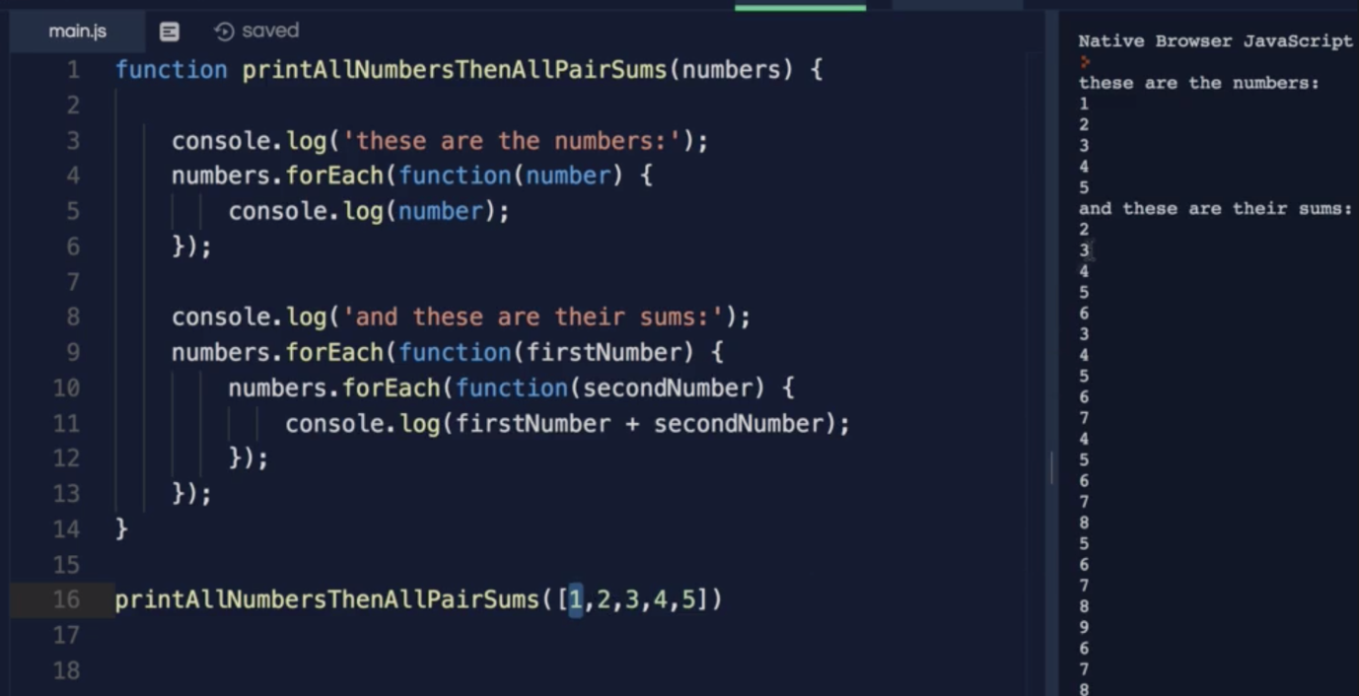

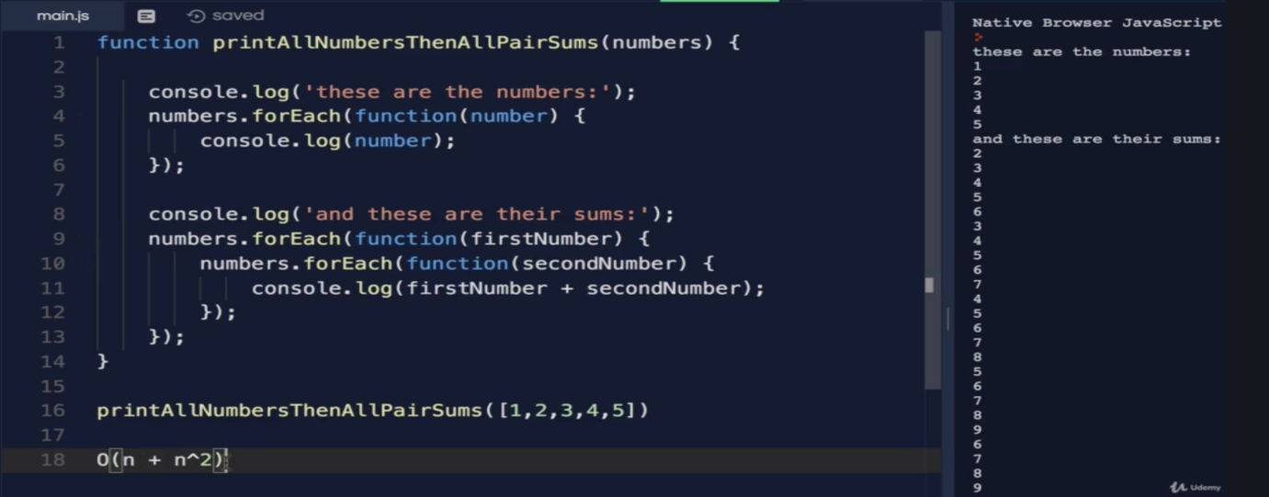

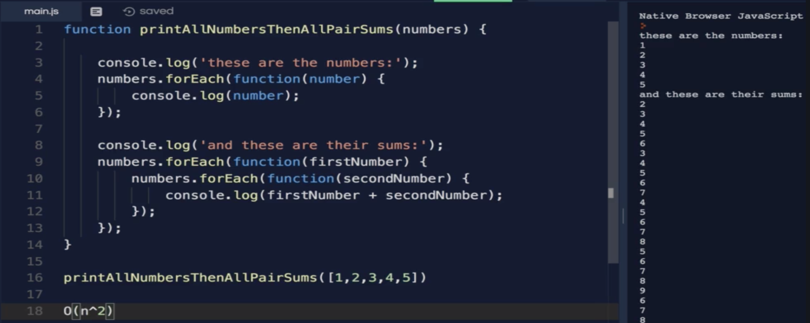

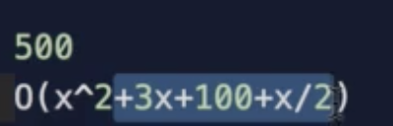 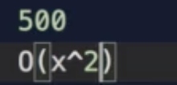

**Note: If nested loop is keep increasing, 3, or 4, keep increase the power term, if it the nested loop is 3, then the Big O is O(n^3)**

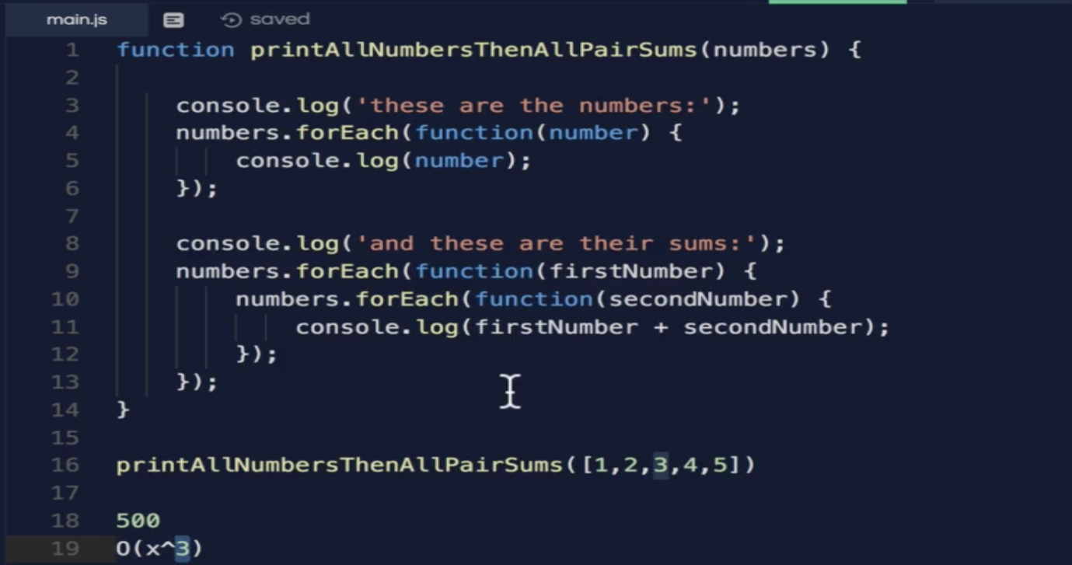

* **Big O Cheat Sheet:**

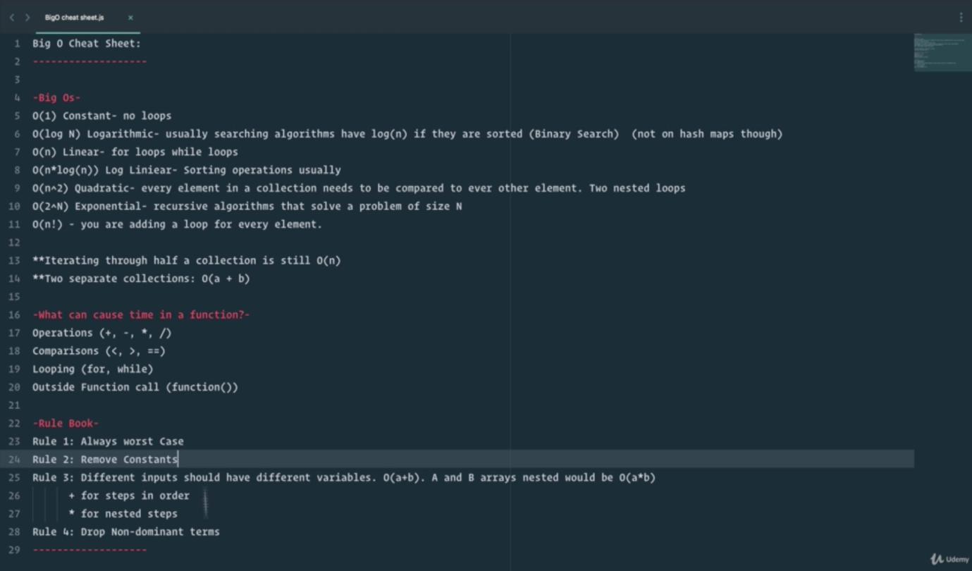

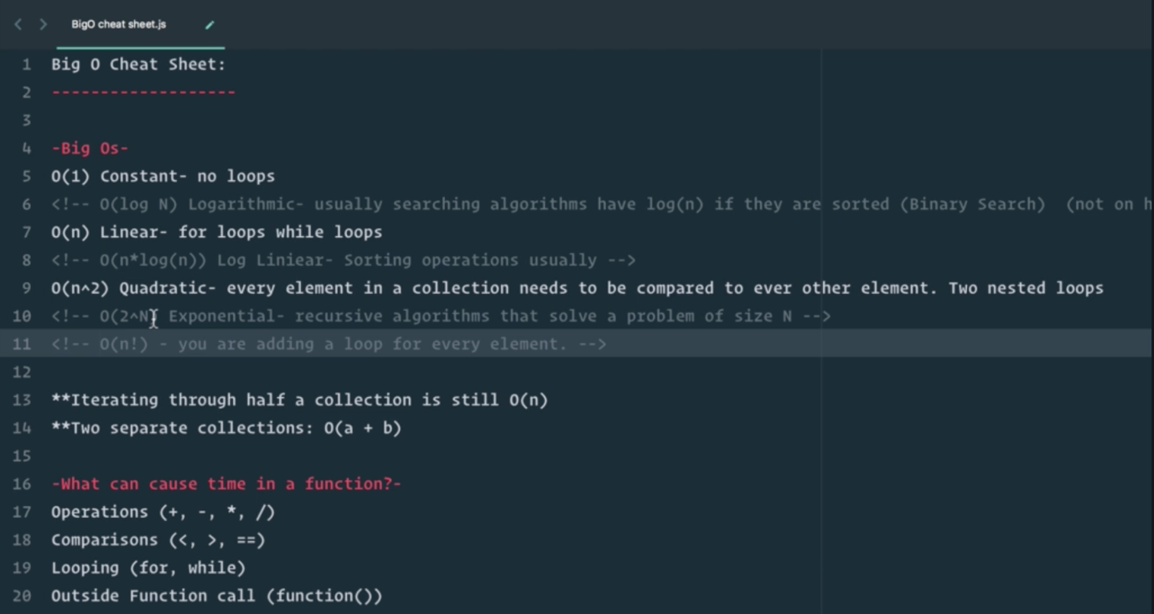

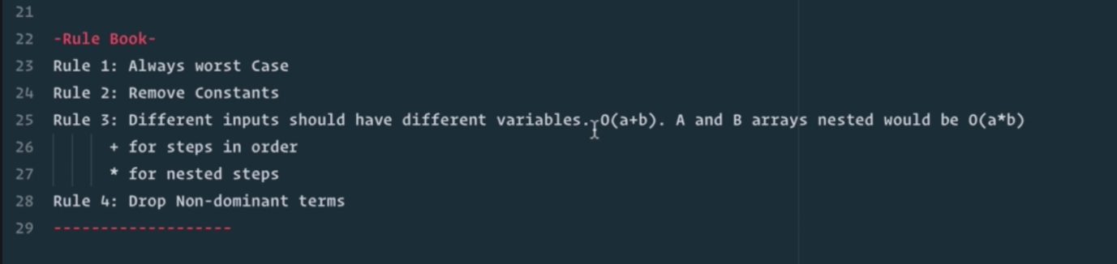

* **What does all mean?**

**With Big O, we are trying to find the performance of the function with more records, not like in the starting point of x and y axis of the graph.**

**We can get more information on below URL.**

[**www.bigocheatsheet.com**](http://www.bigocheatsheet.com)

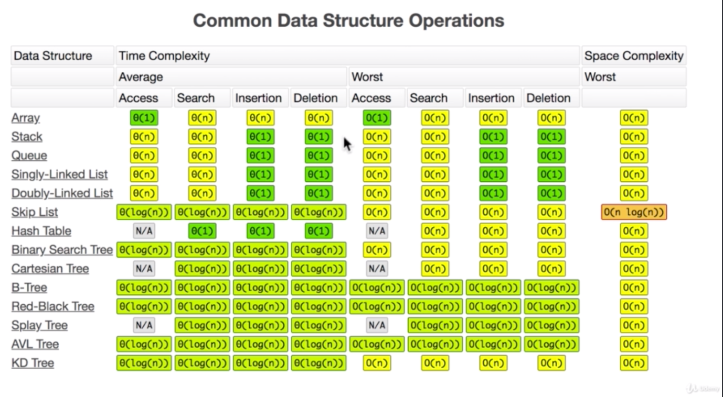



* **O(n!):**

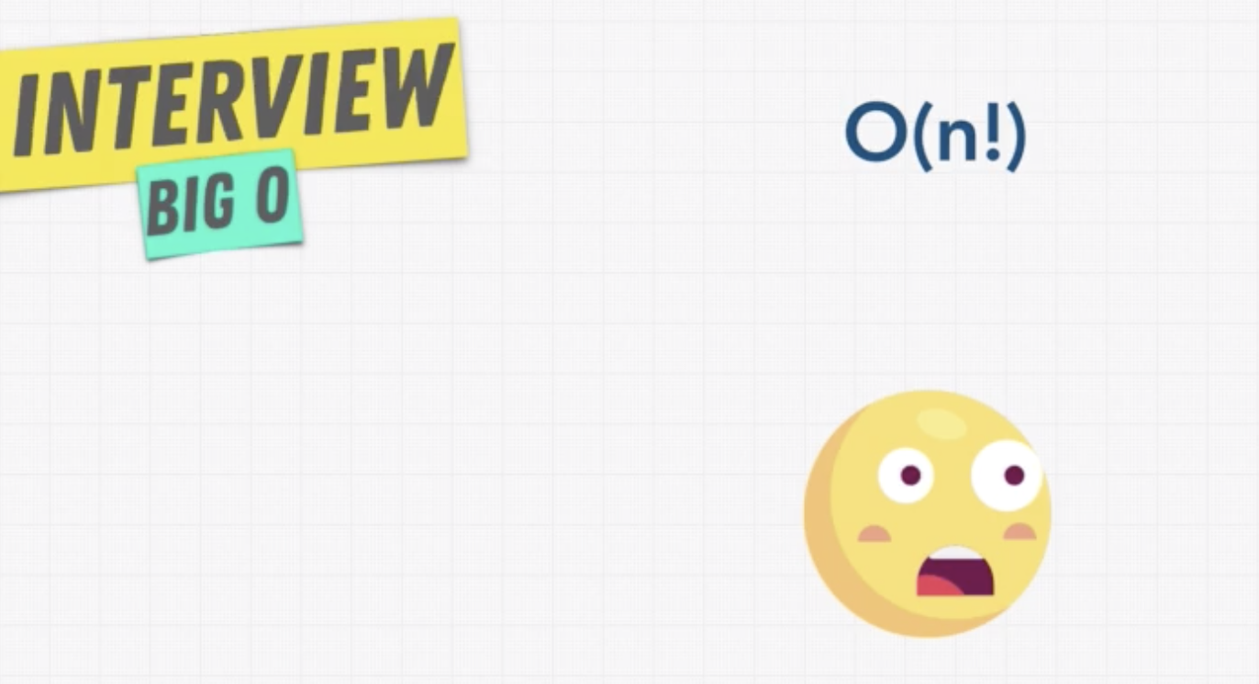

**This is worst Big O an algorithm can have.**

* **3 Pillars of Programming:**

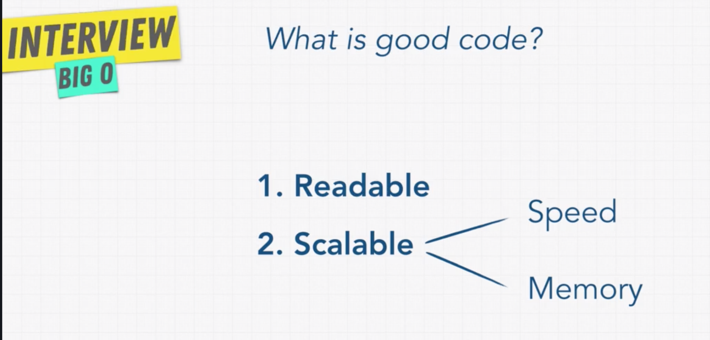



* **Space Complexity:**

Whenever the program runs it uses two kinds of memory heap and stack.

Heap is the place where we store variables.

Stack usually we keep track of function calls.

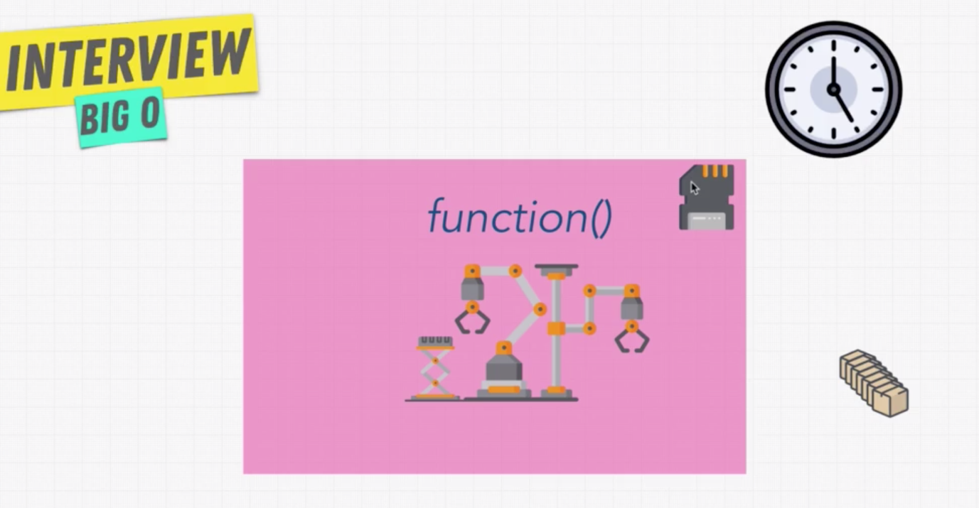

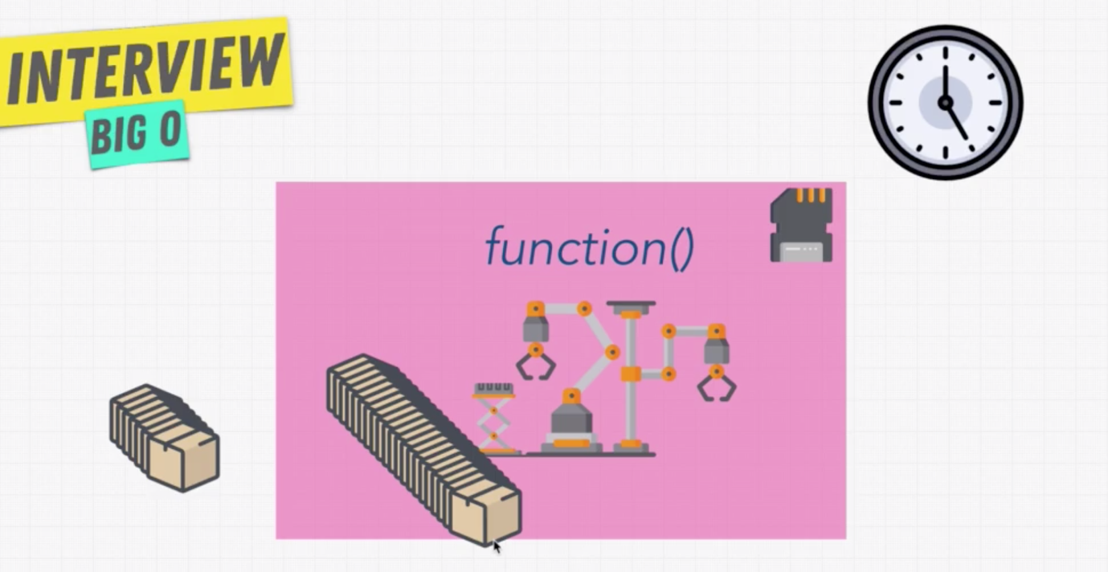

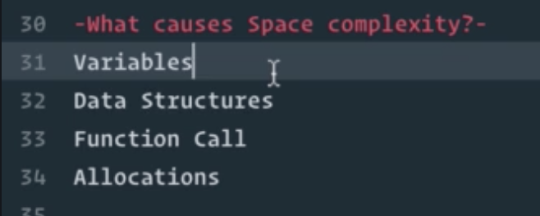

* **Exercise: Space Complexity:**

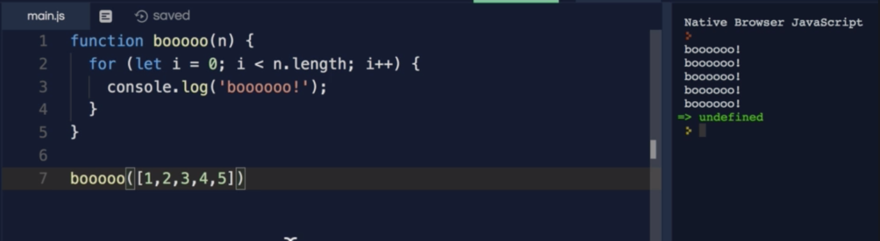

**Time complexity of above function is O(n)**

**What is the space complexity of above function?**

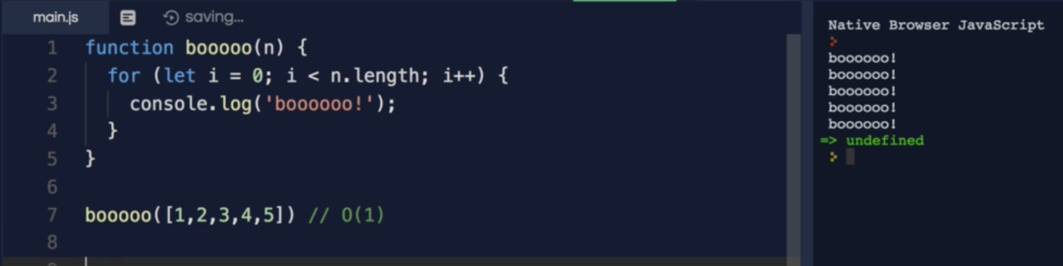

**Because, we are just initializing a single variable named i.**

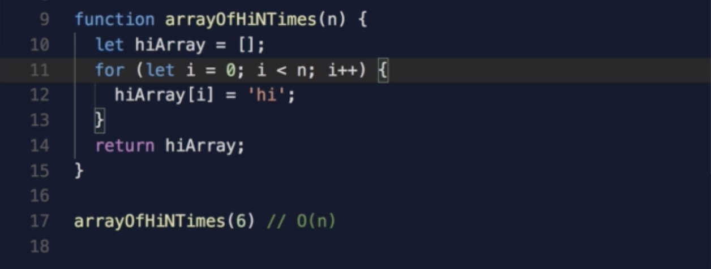

* **Exercise: Twitter:**

If you want to get the oldest and latest tweet.

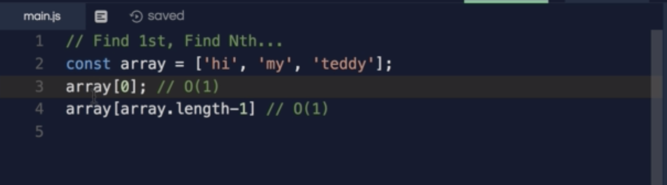

Now compare the dates associated with tweets.

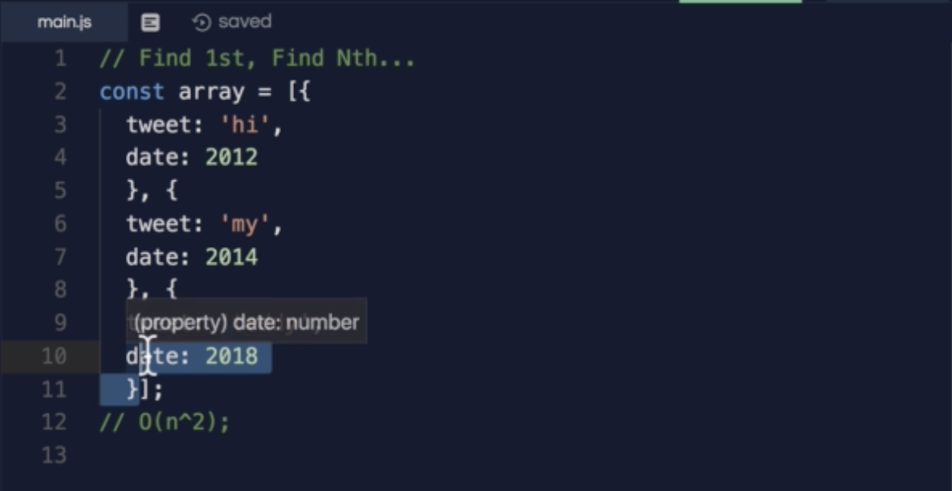

What will be the Big O notation for below code?



This is depends on the specific programming language, because each language implement it on different way.

In JS it will be O(1) as it has a built in property called length;

